**Investment Memorandum: Confidential**

**Project Helios: Proposal for a 10 MW Solar Farm in Rajasthan** **July 20, 2025**

**Modeled by: Priyam Kashyap Baishya**

**1. Executive Summary**

This document outlines an investment opportunity to provide **₹12 Crore in equity capital** for the development and construction of "Project Helios," a **10 MW ground-mounted solar farm** in Rajasthan, India. The project's revenue is secured by a 25-year Power Purchase Agreement (PPA) with the Solar Energy Corporation of India (SECI) at a fixed tariff of **₹2.75/kWh**. The project is strategically positioned to leverage India's strong renewable energy policies and falling technology costs. Based on detailed financial modeling, Project Helios is projected to generate a highly attractive, risk-adjusted **Equity IRR of 37.75%** and a **Net Present Value (NPV) of ₹34.8 Crore**.

**2. Project Overview**

* **Project Description:** A 10 MW ground-mounted solar photovoltaic (PV) power plant.
* **Location:** Rajasthan, India, a region with one of the highest levels of solar irradiance in the country, ensuring high plant productivity.
* **Key Agreement:** A 25-year PPA with SECI guarantees the offtake of 100% of the power generated at a fixed price, ensuring stable and predictable revenue streams.

**3. Market Context & Opportunity**

* **Strong Policy Support:** The project operates within a highly favorable policy environment. India has set a national target of achieving **500 GW of renewable energy capacity by 2030**, with solar power being a key pillar of this strategy. Government bodies like SECI ensure offtake security through long-term PPAs, significantly de-risking investments in the sector.
* **Favorable Cost Trends:** The investment is timed to capitalize on declining technology costs. According to recent industry analysis from sources like BloombergNEF and the International Energy Agency (IEA), the levelized cost of energy (LCOE) from solar in India is among the lowest in the world, driven by falling module prices and efficient construction practices.

**4. Financial Summary**

**4.1. Sources and Uses of Funds** The total required capital for the project is ₹40 Crore, structured with a 70:30 debt-to-equity ratio.

|  |  |  |  |
| --- | --- | --- | --- |
| **Sources of Funds** | **Amount (₹ Cr)** | **Uses of Funds** | **Amount (₹ Cr)** |
| Equity Capital | 12.0 | Total Project Cost | 40.0 |
| Debt Financing | 28.0 |  |  |
| **Total Sources** | **40.0** | **Total Uses** | **40.0** |

**4.2. Key Financial Metrics** The project demonstrates robust financial returns for equity investors.

|  |  |
| --- | --- |
| **Metric** | **Value** |
| **Equity IRR** | **37.75%** |
| **Net Present Value (NPV)** | **₹34.8 Crore** |
| **Payback Period** | **2 Years** |

**4.3. Key Assumption Rationale**

* **PPA Tariff:** The assumed tariff of **₹2.75/kWh** is in line with the weighted average tariffs discovered in utility-scale solar auctions conducted by SECI in late 2024 and early 2025.
* **Capital Cost (CAPEX):** The projected CAPEX of **₹4.0 Crore/MW** is based on current market data for Tier-1 modules and balance-of-system components, reflecting recent project costs in Rajasthan.

**4.4. Projected Financials** The project is projected to be profitable, with stable cash flows generated over the 25-year PPA term.

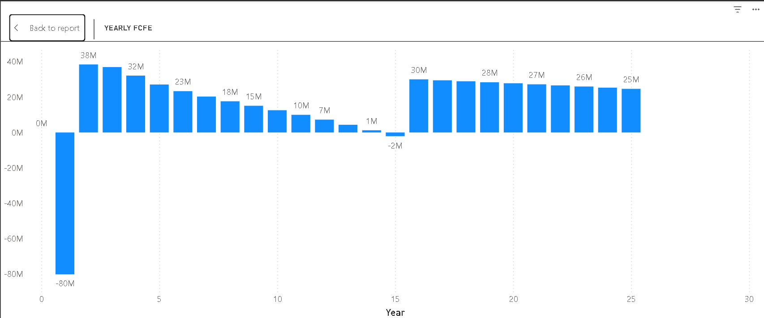 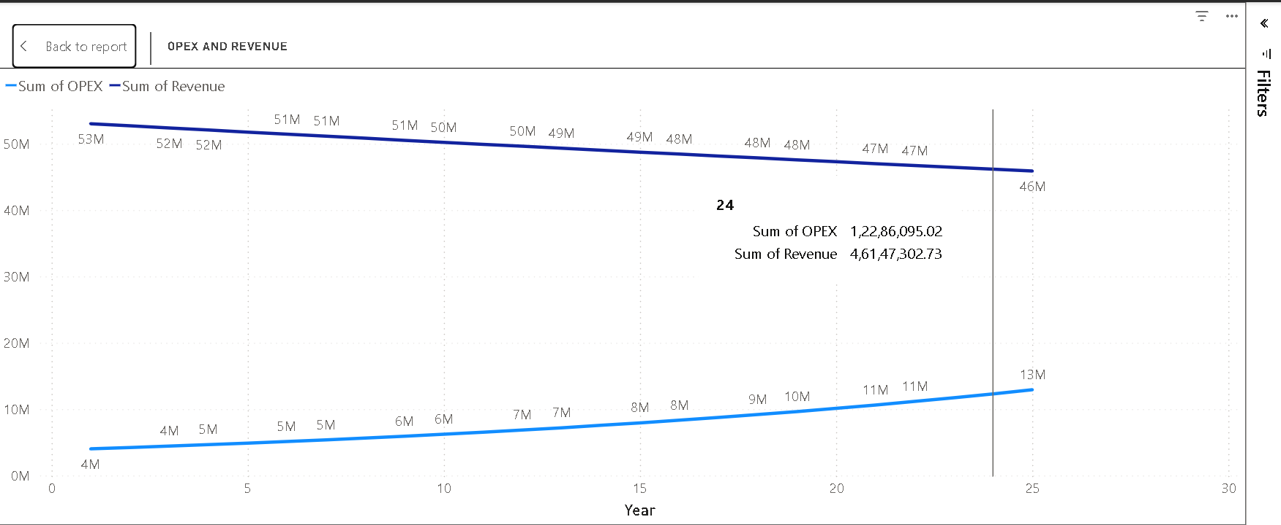

**5. Risk Analysis & Mitigation**

A summary of key risks and the strategies in place to mitigate them.

* **Construction Risk:** Risk of delays or cost overruns.
  + **Mitigation:** Hiring an experienced EPC (Engineering, Procurement, and Construction) contractor with a fixed-price, date-certain contract.
* **Operational Risk:** Risk of the plant generating less electricity than expected.
  + **Mitigation:** Using Tier-1 equipment suppliers with performance guarantees; having a professional O&M (Operations & Maintenance) team.
* **Counterparty Risk:** Risk of the entity buying the power failing to pay.
  + **Mitigation:** The PPA is with the **Solar Energy Corporation of India (SECI)**. SECI has a strong credit rating from domestic agencies like ICRA and a proven track record of timely payments, making it one of the most secure counterparties in the Indian power sector.